12 Days of Fitness Challenge

Dear Parent/Guardian,

Staying active during the cold winter months can be a challenge!

The 12 Days of Fitness challenge presents a fun way to be active indoors leading up to the holiday season. This challenge was inspired by the 12 Days of Christmas song – each day, you introduce a new activity and complete it along with the previous day activities.

Encourage your child to lead this activity for the family. Embrace this fitness challenge to increase your heart rate, try different exercises, and have fun!

Here is how it works:

- Complete the day 1 exercise and use the tracking sheet to mark down the number of family members who participated. Write your initials for each day.
- On the next day, complete the day 2 exercise, followed by the day 1 exercise. Track the number of family members who participated.
- Continue each day, adding a new exercise to the ones from previous days. By day 12 you begin with the day 12 exercise and complete each exercise all the way down to day 1.
- After finishing all 12 days of fitness, your child will bring the completed and initialed form to school to hand to their teacher.
12 Days of Fitness Tracking Sheet

Name:___________________________

Day and Activity | # of Participants and Parent Initial | Day and Activity | # of Participants and Parent Initial
Day 1: 1 tuck jump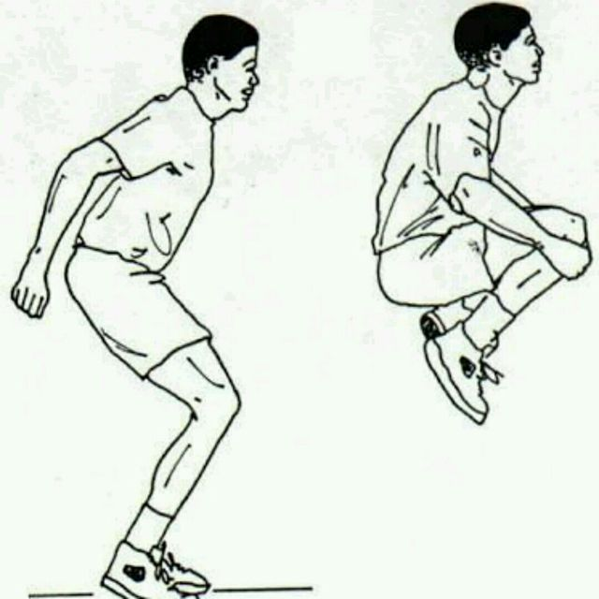 |  | Day 7: 7 arm circles and days 6 to 1 exercises  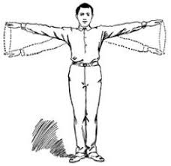
Day 2: 2 toe touches and day 1 exercises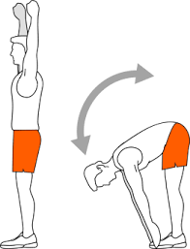 |  | Day 8: 8 knee lifts and days 7 to 1 exercises  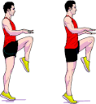
Day 3: 3 muscle poses and days 2 and 1 exercises |  | Day 9: 9 bum kicks and days 8 to 1 exercises  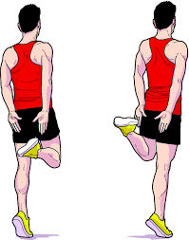
Day 4: 4 table push ups and days 3 to 1 exercises  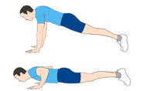 |  | Day 10: 10 calf raises and days 9 to 1 exercises  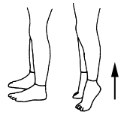
Day 5: 5 crunches and days 4 to 1 exercises  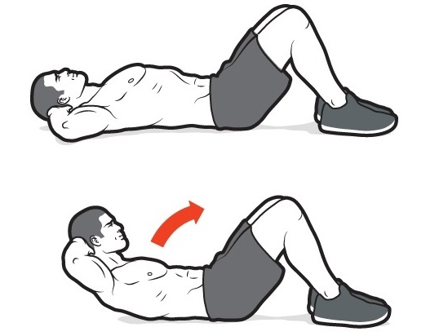 |  | Day 11: 11 chair squats and days 10 to 1 exercises  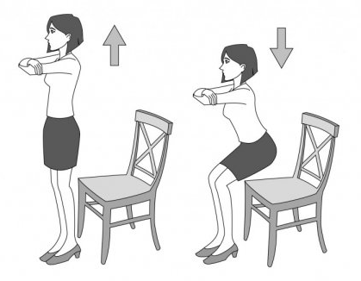
Day 6: 6 shoulder shrugs and days 5 to 1 exercises  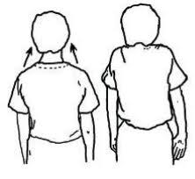 |  | Day 12: 12 jumping jacks and days 11 to 1 exercises  