About the I Tried It cards
- Keep sheets small so they are easily transported home and are quick and easy to read

- be sure to have a rating system for students so parents can see how much their child liked the item

- Include a picture so parents and students can easily recognize the item in the store

Template Example
AVOCADO
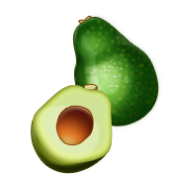

My Rating:
- An avocado is a fruit and not a vegetable! It is a member of the berry family.

- Avocados contain oleic acid, a monounsaturated fat that may help to lower cholesterol.

- Avocados are a good source of potassium, a mineral that helps regulate blood pressure.

- Avocados are good in salads, sandwiches, smoothies, and are the main ingredient for guacamole.

Insert Food Name
Food Picture

My Rating:

- Interesting/fun facts about food.
- Recommended ways to eat/prepare/enjoy food
- Highlight key nutrients/vitamins/etc.

