Sleep to Success Bulletin Board

Theme:
This campaign teaches students to be mindful and aware of their sleep by learning and thinking about the importance of dreaming.

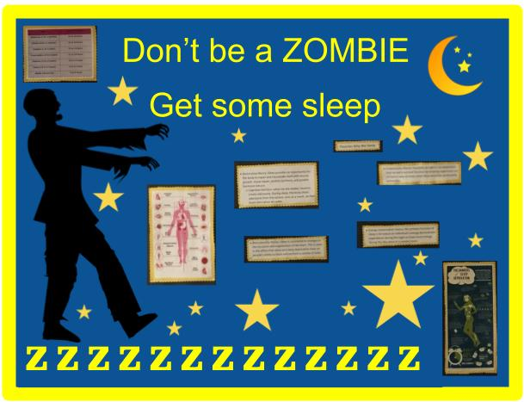
Bulletin Board Example:

Use the fun facts on the last page to highlight the importance of sleep on a Don’t be a Zombie bulletin board. Add a zombie, and moon and stars as well.

Classroom Instructions:
- Hold a classroom discussion with students about Rapid Eye Movement (REM) sleep. Important facts to cover are:
  - REM stands for Rapid Eye Movement sleep because the eyes are moving underneath the eyelids while sleeping occurs.
  - About 25% of all sleep is REM sleep. All other sleep is referred to as non-REM sleep. Non-REM sleep is the stage where our bodies recover from the fatigue of the previous day. During REM sleep, the brain is as active as it is during waking hours, and this is where most dreams occur.¹
- Discuss with students the importance of sleep for their health and wellbeing.
  - 5-13 year olds should get 9-11 hours of sleep each night and 4-17 year olds need 8-10 hours.
  - Dreaming boosts the ability to be creative and problem solve.
  - Dreaming can help students to regulate their emotions. This is thought to occur because dreams are an outlet for frustrations and desires that happened during the previous day.
- Ask students if they think they get enough sleep. Encourage them to discuss strategies they know of to ensure they get a good sleep each night. Some suggestions to get the conversation rolling are:
  - Going to bed at the same time each night.
  - Sleeping in a dark room.
- Ask students how they feel when they don’t get a good night of sleep. Discuss.

Bulletin Board Instructions:
- Cut out the attached title, zombie, moons, stars, the fun facts about sleep.
- Arrange on the bulletin board

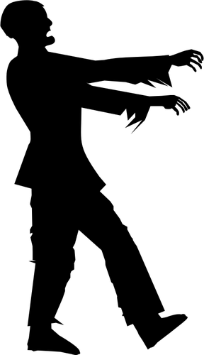
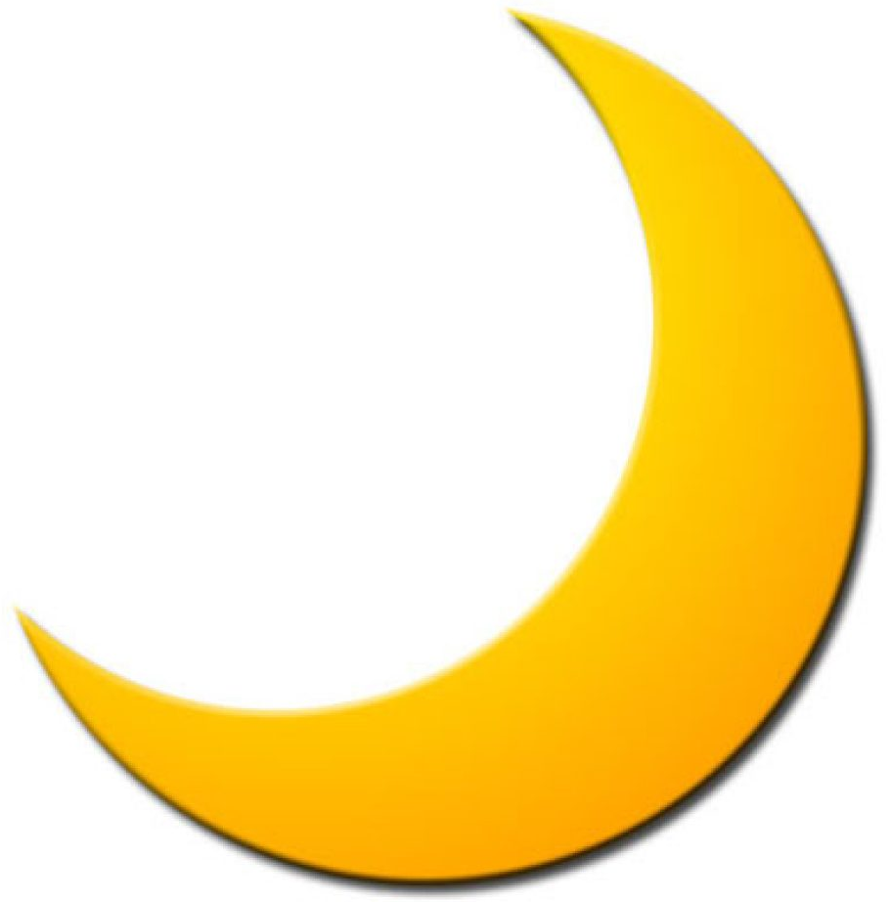
Fun facts:

Many people throughout history have invented tons of different things because of an idea they got from their dreams.

You dream every night, even if you don’t remember any of it!

The amount of sleep you should get depends on your age. Children (ages 5-13) should get 9-11 hours of sleep a night. Youth (ages 14-17) should get 8-10 hours of sleep a night. Adults (ages 18+) should get 7-9 hours of sleep a night.

Rapid Eye Movement sleep, also known as REM, is the period of sleep where most of our dreams happen! REM helps with creativity, problem solving, and memory.
DON’T BE A ZOMBIE
GET SOME SLEEP

Boivin, D. B. (2012). Sleep and you: Sleep Better, Live Better. Montreal: Dundurn Toronto.
https://csepguidelines.ca/wp-content/themes/csep2017/pdf/Canadian24HourMovementGuidelines2016_2.pdf
https://www.ncbi.nlm.nih.gov/pubmed/11014055
Griffin, J., & Ivan, T. (2004). Why we dream: The Definitive Answer. Human Givens Publishing

