Address Your STRESS

Make individual copies of the bingo cards and distribute them to teachers for their students. They should tell the students how many they can complete in one day. Put one copy up on the bulletin board. Remove this header before printing, and the BINGO card will fit on one page.

See if you can get a BINGO! Cross off all the activities below that help release stress! When you’ve completed all the activities, pass the sheet to your teacher for a chance to win a prize!

I gave a friend a hug (or air high five) | I got some sun! Vitamin D can help reduce stress | Going for a walk is an exercise that reduces stress | I told a joke and made someone laugh
I made a list of some great things in my life | Jumping is an exercise that reduces stress | We had supper as a family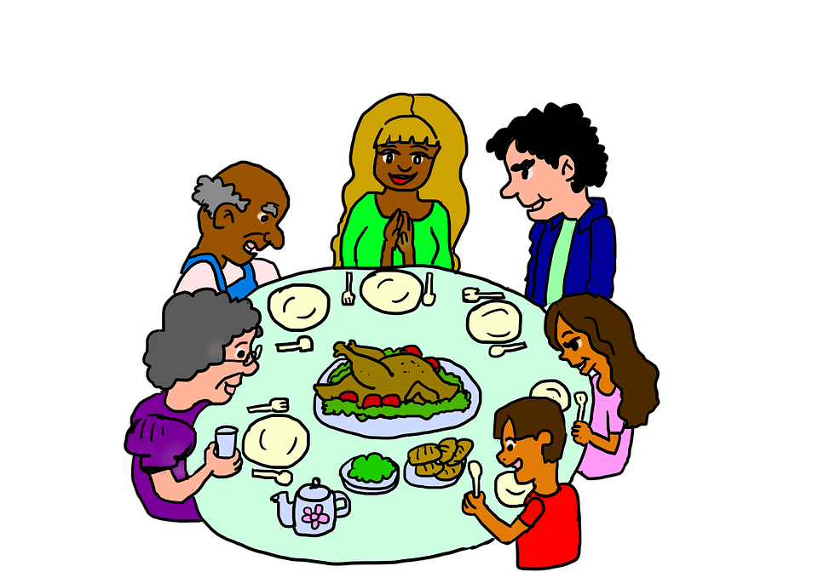 | Running is an exercise that reduces stress
Skipping is an exercise that reduces stress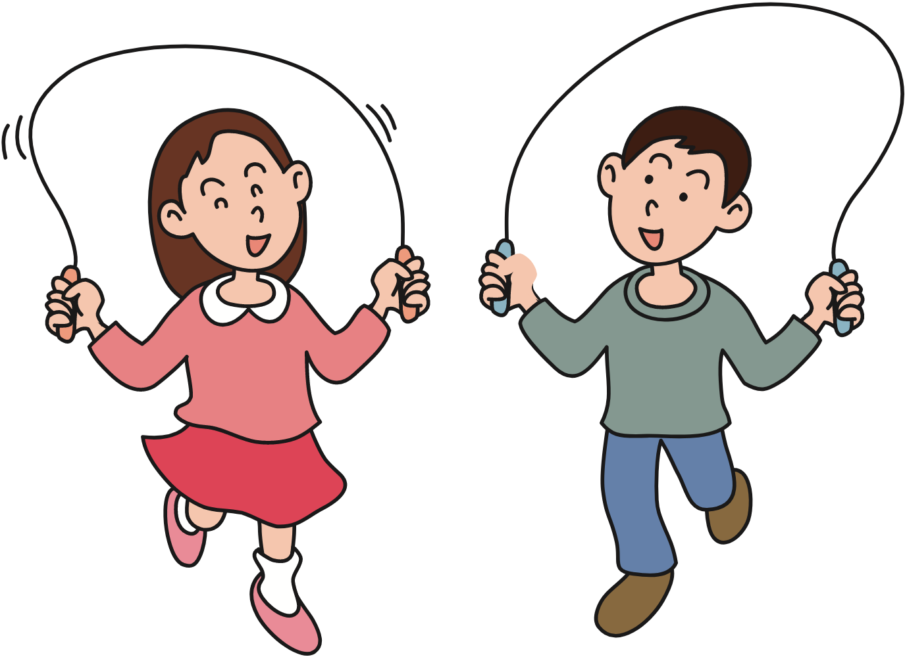 | Eating healthy foods can help you feel better.Try Broccoli! | Sit-ups are an exercise that can reduce stress | Trying something new can make you feel great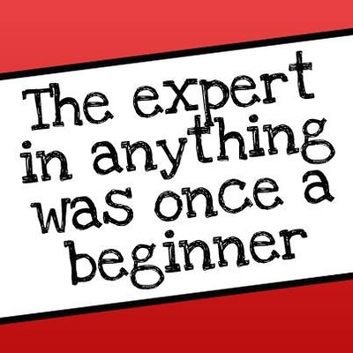
I talked to someone about something I was worried about. | I listened to someone tell me about their problem. 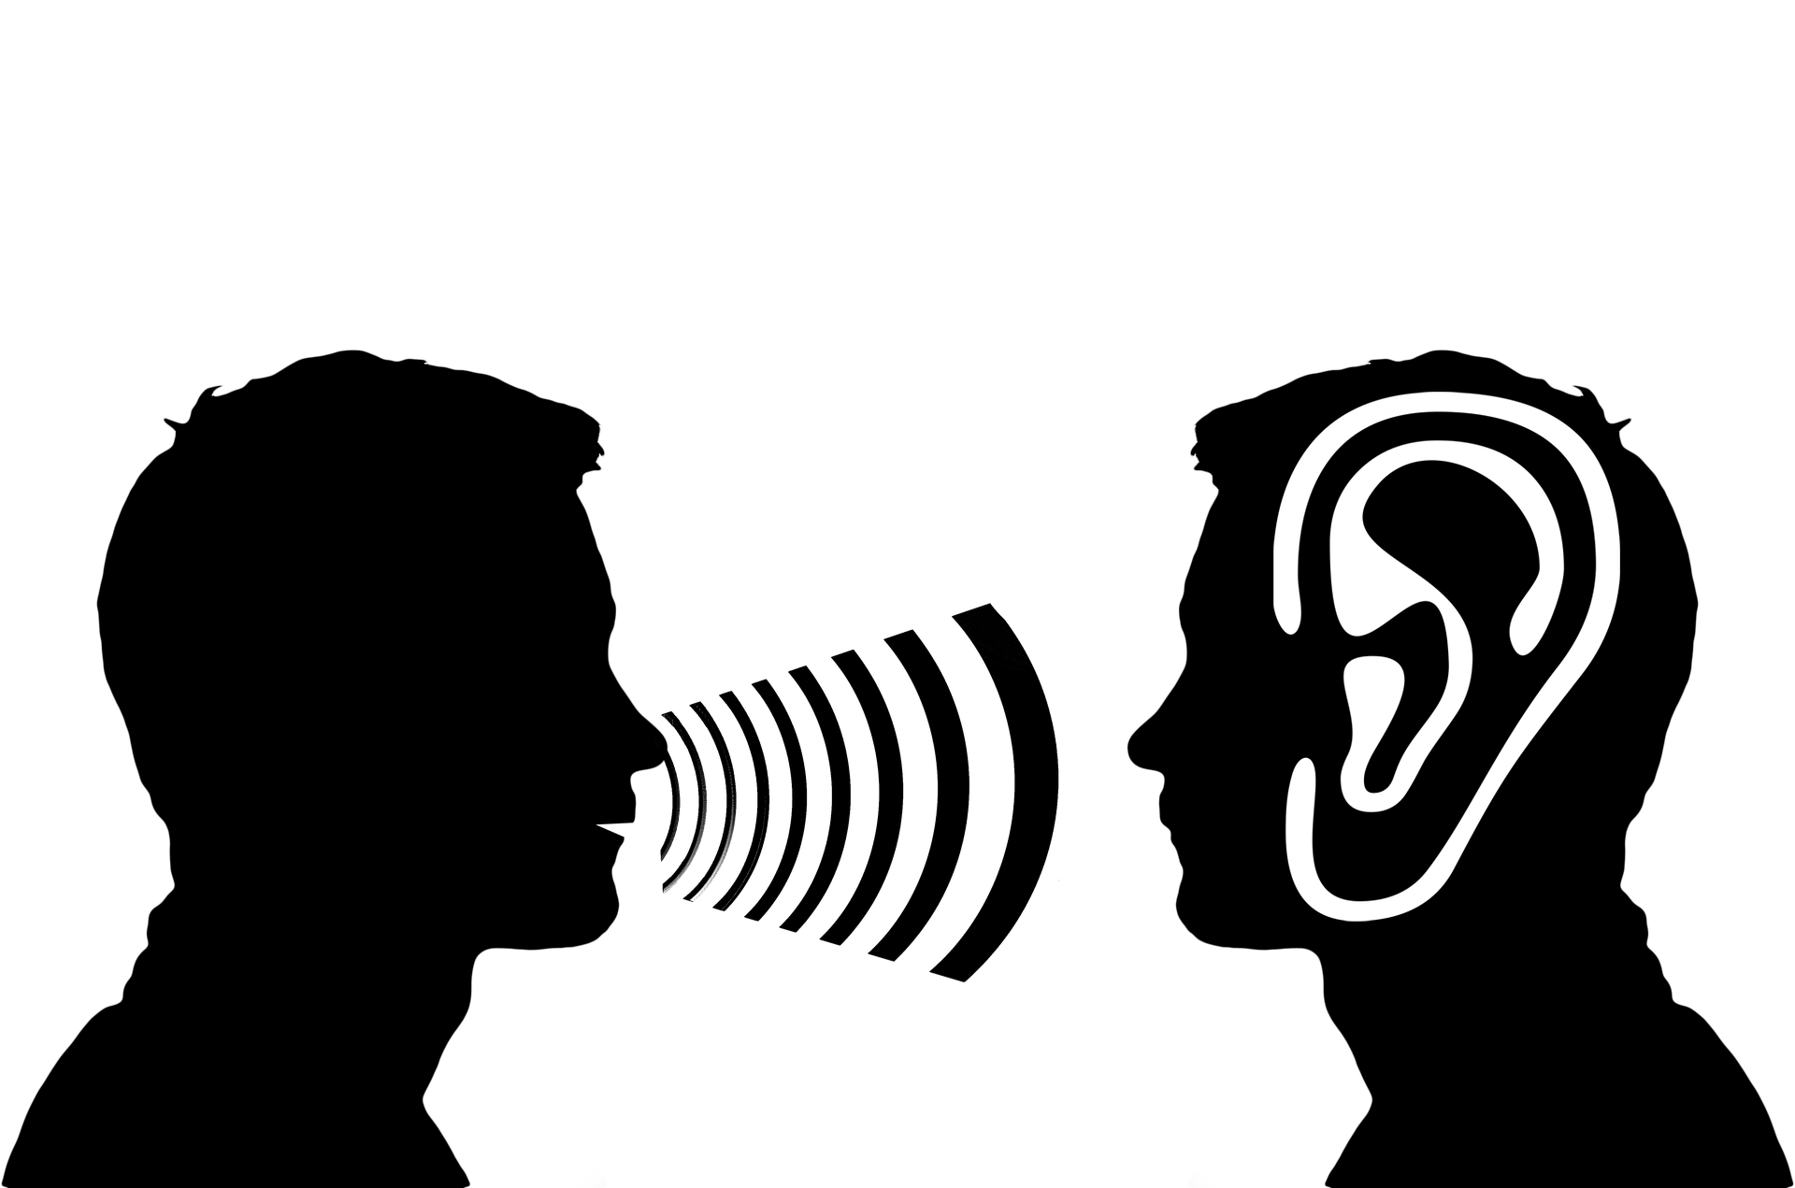 | I did some yoga poses! | I got a good sleep last night  