Minimizing Screen Time Challenge
Instructions and Tracking Sheet

Dear Parent/Guardian,

Growing up in the digital age can make it difficult for kids -- and their parents -- to put their screens down and choose to be active instead.

The Minimizing Screen Time challenge is a fun way to learn about sedentary behaviour and physical activity guidelines (from CSEP) and allow you to track where your family fits in each category. This is important as it has been proven that less sedentary time can increase academic success, improve social skills, and lead to more time spent being physically active. This challenge will involve tracking how much time is spent on both recreational screen and physical activity each day for the next two weeks, with the goal of meeting the CSEP guidelines.

Encourage your child to lead this activity for your family. Embrace this challenge to try and increase family time spent being active.

Here is how you and your family can participate:

- Use the Daily Guidelines for Each Age Group chart provided to determine how much time should be spent being physically active versus sedentary for each participant age group. Use the tracking sheet (attached) to record.
- Every day, have each participant record how many minutes they spent being physically active and how many minutes they spent on recreational screen time. Use the tracking sheet (attached) for the next two weeks to keep track. At the end of each week, check how many family members were able to stay within both sets of guidelines.
- After the 2-week period, staple your 2 tracking sheets together and send them back to school with your child where your family’s impressive health efforts will be displayed for their class to see.
Daily Guidelines for Each Age Group

Age | Physical Activity Guidelines | Sedentary Behaviour Guidelines
0-2 years | 180 minutes of physical activity at any intensity spread throughout the day | Screen time is not recommended
2-4 years |  | Screen time should be limited to under 1 hour per day (less is better)
5-11 years | 60 minutes of moderate to vigorous intensity physical activity daily | Limit recreational screen time to no more than 2 hours per day (less is better)
12-17 years
18 years and older | 150 minutes or more of moderate to vigorous intensity aerobic physical activity per week | No official guidelines - limit recreational screen time to no more than 2 hours per day (less is better)

Here are some helpful tips for this challenge provided by CSEP on how to replace sedentary behaviour with active behaviour:
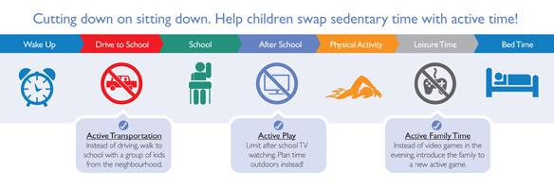

Tracking Sheet
Names |  | Partipant 1: __________ | Partipant 2: __________ | Partipant 3:  __________ | Partipant 4: __________ | Partipant 5: __________
Activity |  | Recommended number of minutes per day according to the CSEP chart provided
 | Screen Time
 | Physical Activity
Week 1 |  | Number of Minutes Spent Completing the Activity
Day 1 | Screen Time
 | Physical Activity
Day 2 | Screen Time
 | Physical Activity
Day 3 | Screen Time
 | Physical Activity
Day 4 | Screen Time
 | Physical Activity
Day 5 | Screen Time
 | Physical Activity
Day 6 | Screen Time
 | Physical Activity
Day 7 | Screen Time
 | Physical Activity
Did you meet the guidelines this week?(Yes or No)
Week 2 |  | Number of Minutes Spent Completing the Activity
Day 1 | Screen Time
 | Physical Activity
Day 2 | Screen Time
 | Physical Activity
Day 3 | Screen Time
 | Physical Activity
Day 4 | Screen Time
 | Physical Activity
Day 5 | Screen Time
 | Physical Activity
Day 6 | Screen Time
 | Physical Activity
Day 7 | Screen Time
 | Physical Activity
Did you meet the guidelines this week?(Yes or No)

http://csepguidelines.ca/
http://www.screensmartschools.ca
These guidelines have been summarized for the purpose of this challenge. For the complete and detailed guidelines, visit www.csepguidelines.ca

